80% Vaccination Uptake

Population-wise projections

Cervical Cancer Incidence
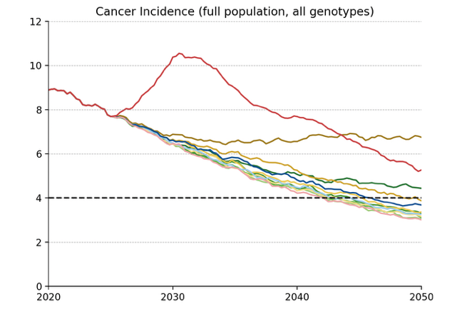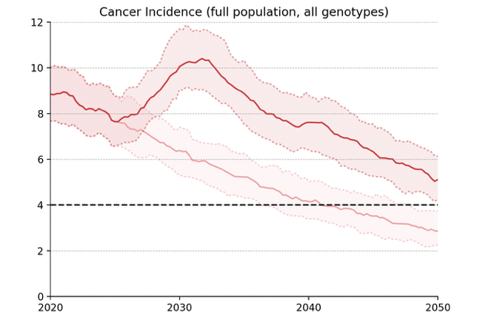
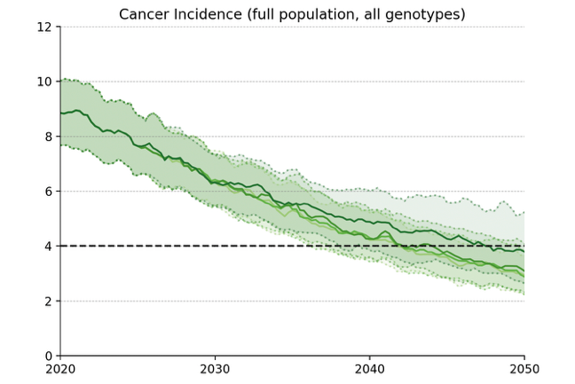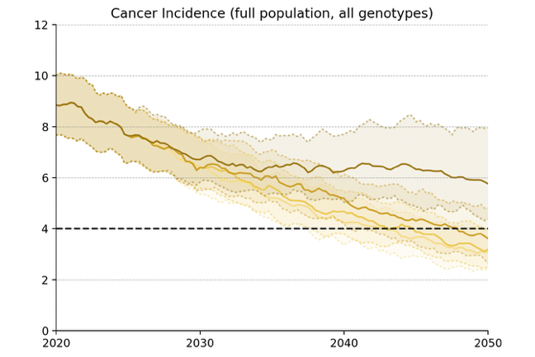
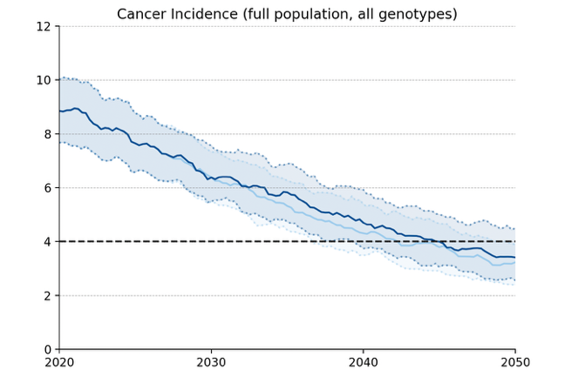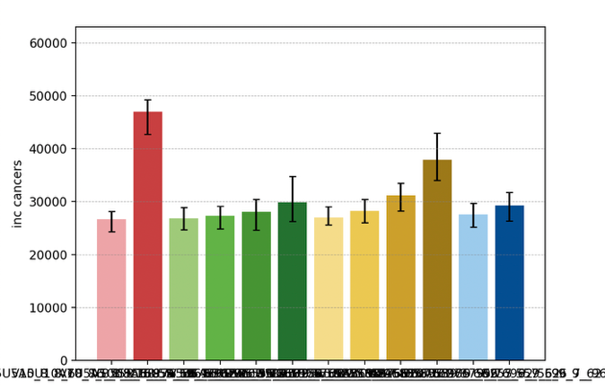
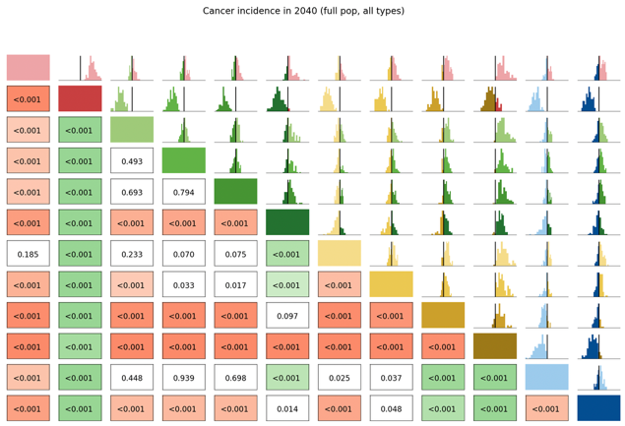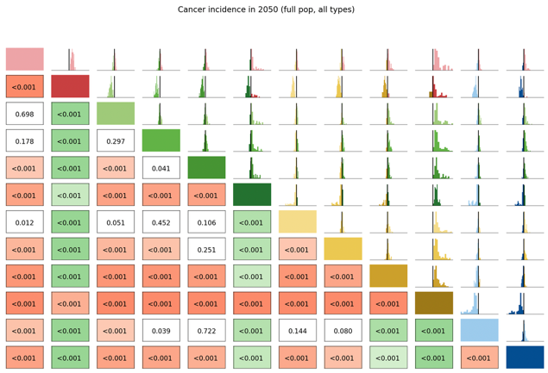

Long Term Undiagnosed Prevalence
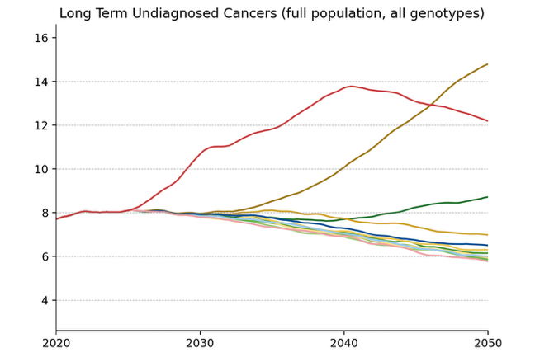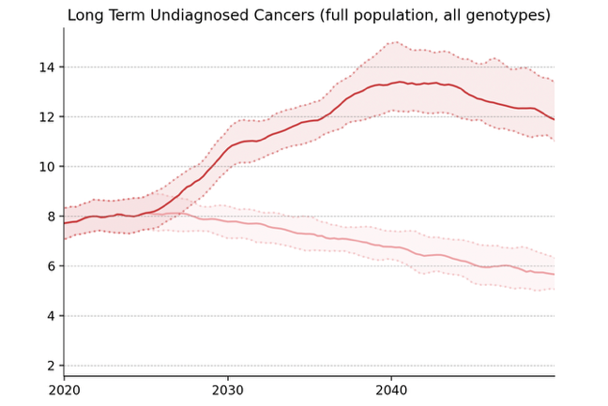
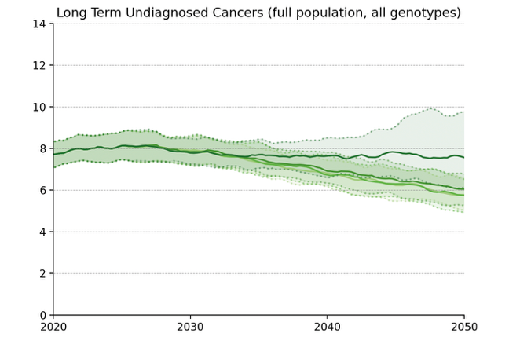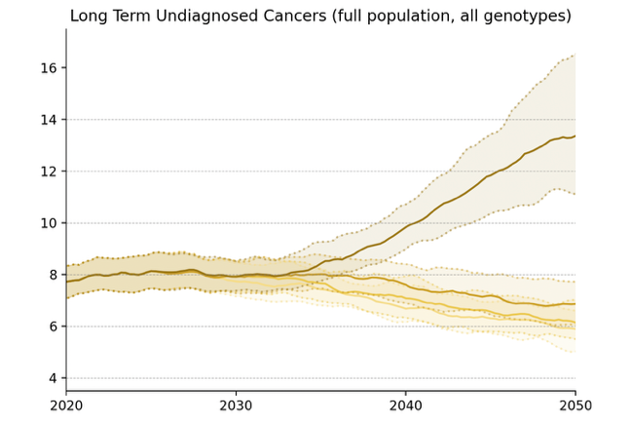
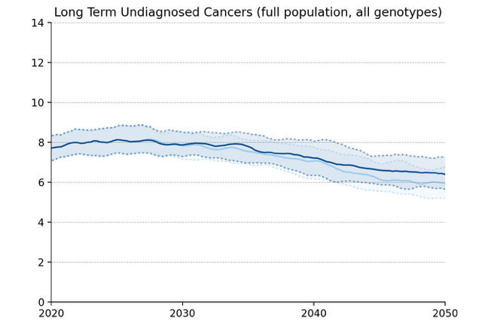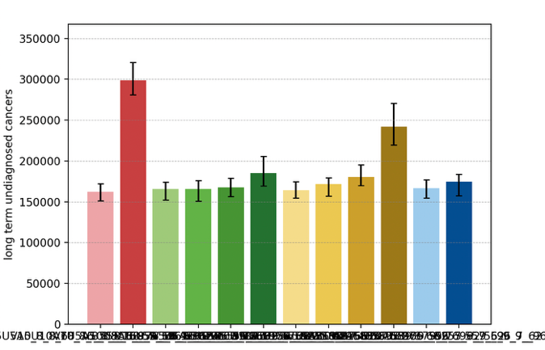
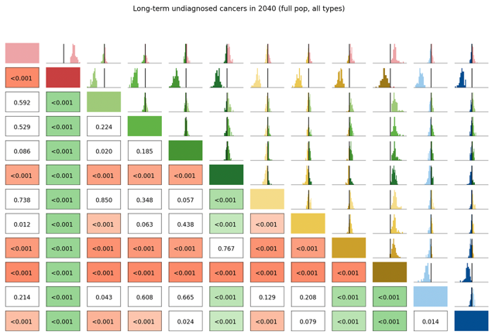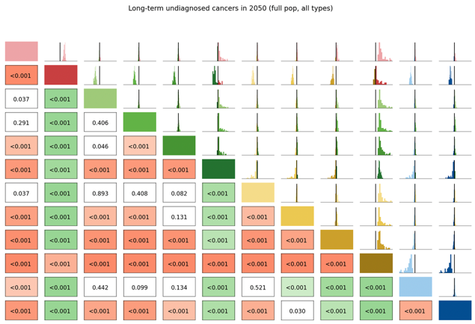

Number of Routine Screens
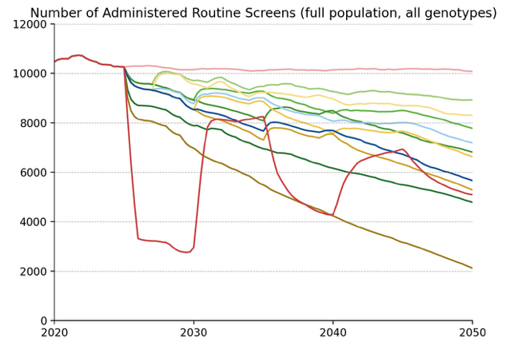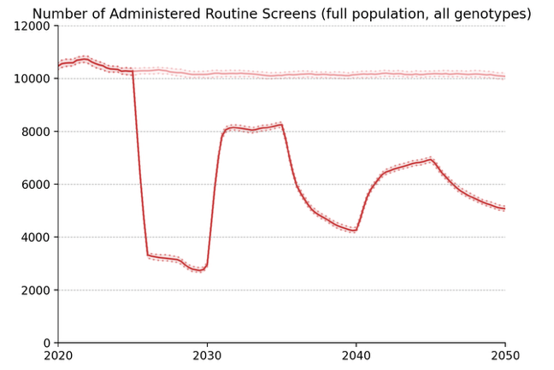
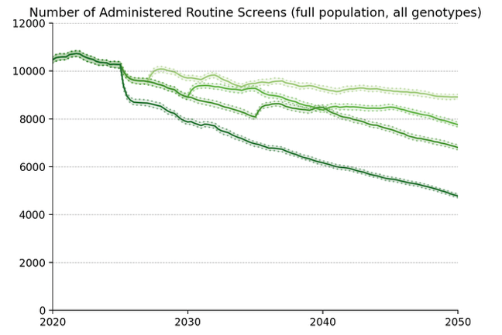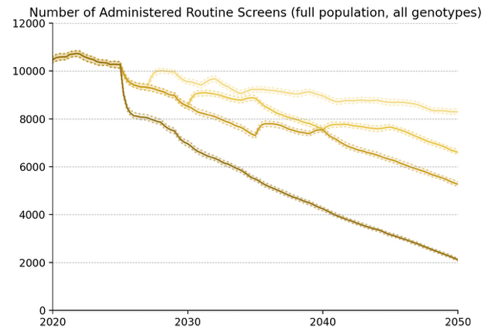
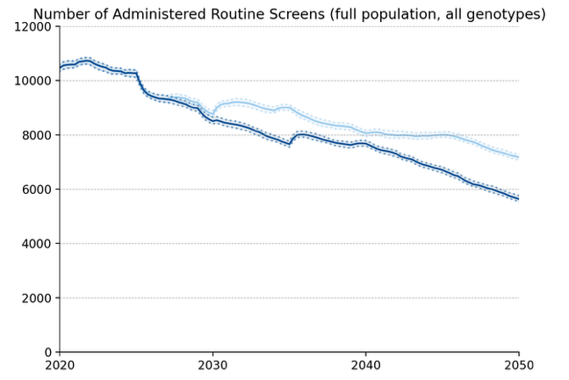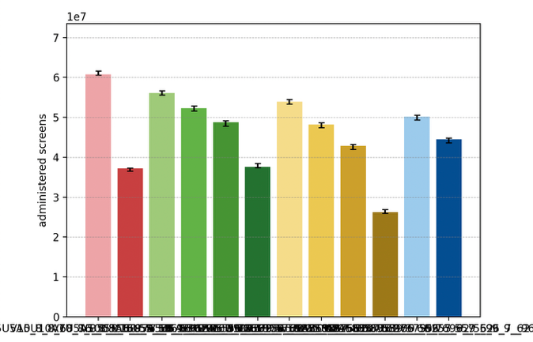

Average Number of Screens per Diagnosed Cancer, 2030-50
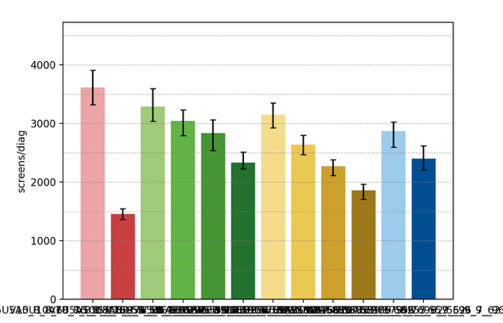

Elimination Probability Table
alg | Elimination Year: Median [LQ, UQ] (_8) | 2040.25 Elimination Probability (_8) | 2050.25 Elimination Probability (_8)
V5U5A5 | 2046 [2043, 2049] | 0.100 | 0.753
V7U5A5 | 2046 [2043, 2050] | 0.123 | 0.765
V10U5A5 | 2048 [2044, 2051] | 0.134 | 0.697
V15U5A5 | 2047 [2043, 2054] | 0.100 | 0.663
V_U5A5 | 2052 [2046, 2055] | 0.067 | 0.461
V7U7A5 | 2047 [2044, 2051] | 0.100 | 0.697
V10U10A5 | 2049 [2045, 2053] | 0.055 | 0.629
V15U15A5 | 2051 [2048, 2055] | 0.033 | 0.438
V_U_A5 | 2055 [2055, 2056] | 0.022 | 0.033
V10U7A5 | 2048 [2045, 2052] | 0.112 | 0.708
V15U10A5 | 2050 [2045, 2055] | 0.055 | 0.539
V10U10A10 | 2055 [2054, 2055] | 0.022 | 0.033
Maximum margin: 0.10363266055508763

Vaccinated Population projections

Cervical Cancer Incidence
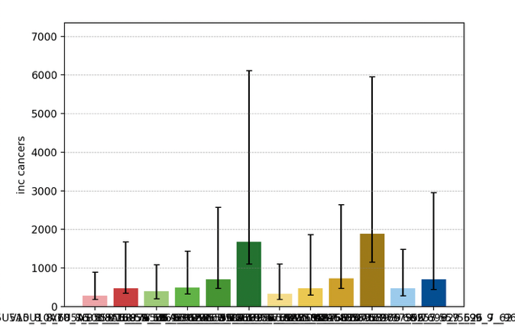
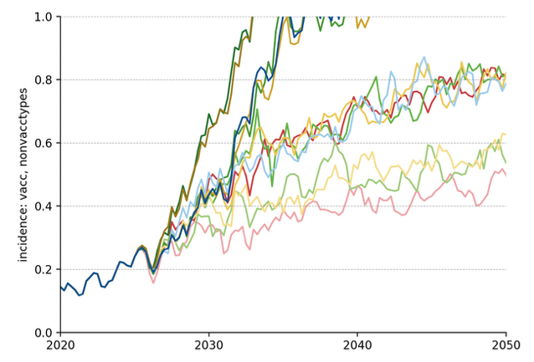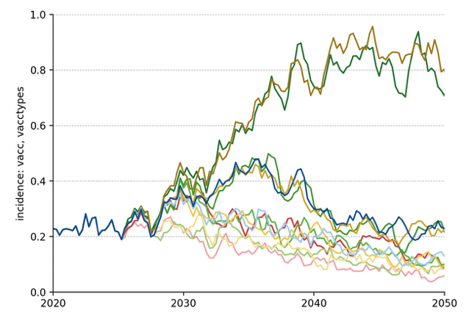
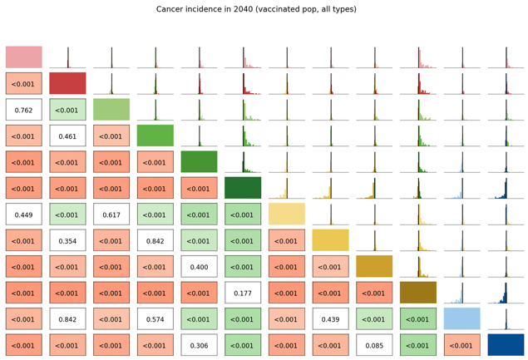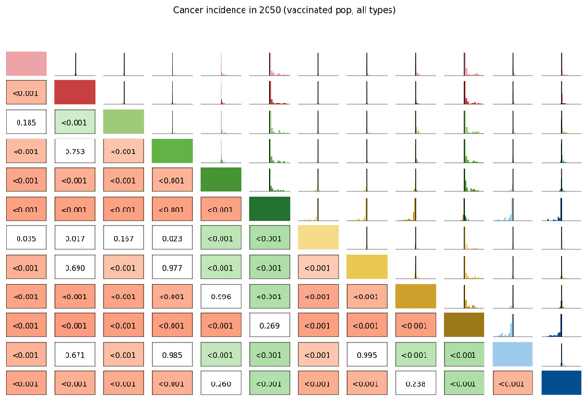

Long Term Undiagnosed Prevalence
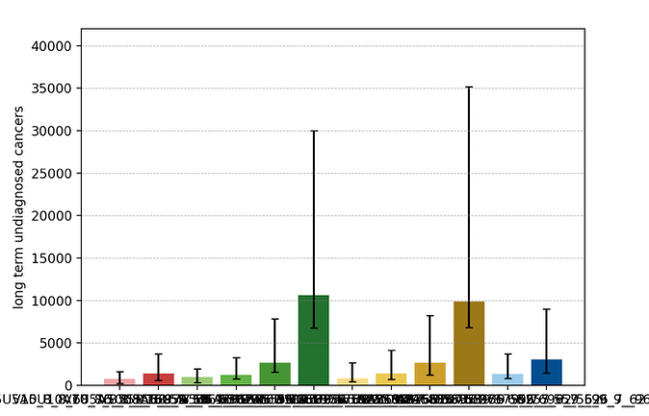
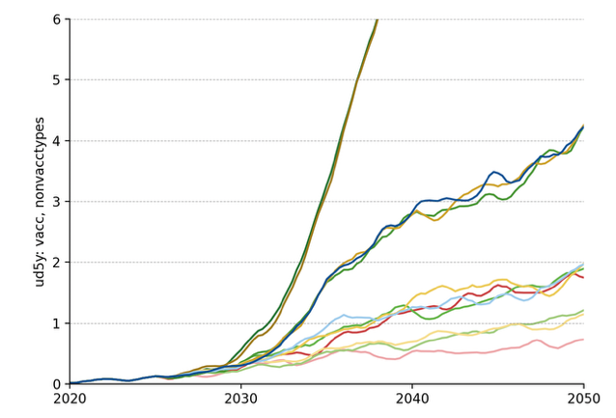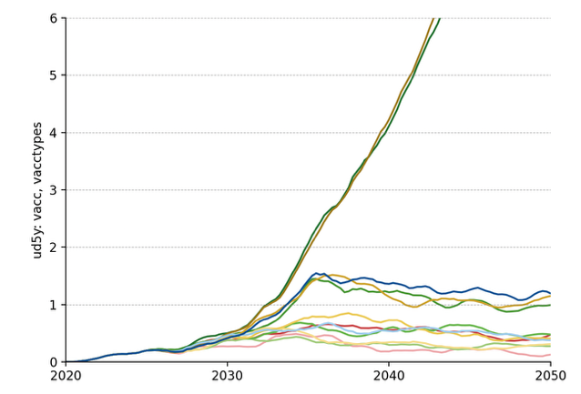

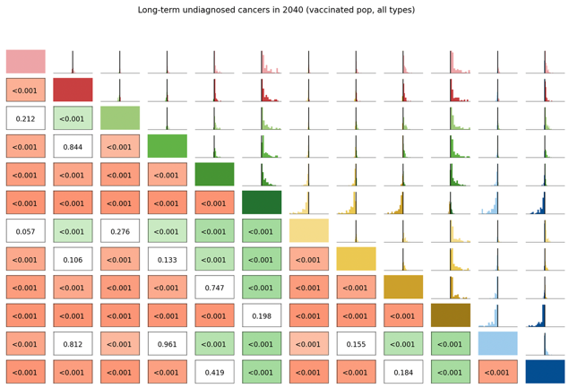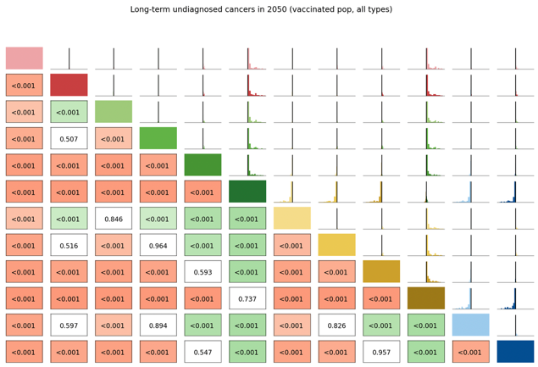

Number of Routine Screens
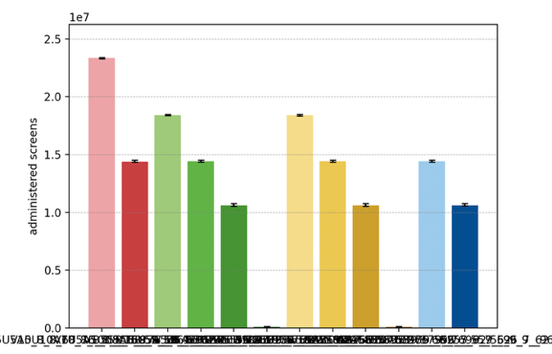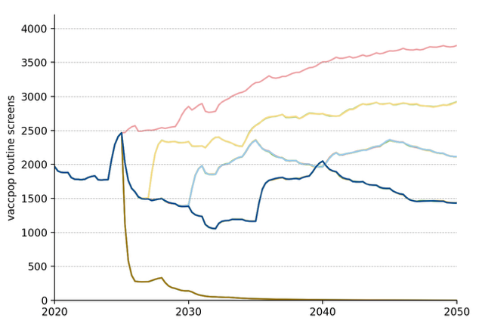

Average Number of Screens per Diagnosed Cancer, 2030-50
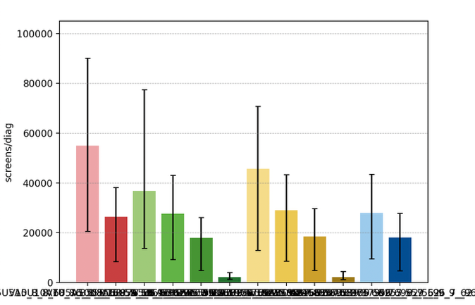

Elimination Probability Table
alg | Elimination Year: Median [LQ, UQ] (_8) | 2040.25 Elimination Probability (_8) | 2050.25 Elimination Probability (_8)
V5U5A5 | 2008 [2008, 2008] | 0.945 | 0.978
V7U5A5 | 2008 [2008, 2008] | 0.911 | 0.911
V10U5A5 | 2008 [2008, 2008] | 0.810 | 0.832
V15U5A5 | 2008 [2008, 2008] | 0.765 | 0.776
V_U5A5 | 2008 [2008, 2056] | 0.584 | 0.629
V7U7A5 | 2008 [2008, 2008] | 0.888 | 0.911
V10U10A5 | 2008 [2008, 2008] | 0.821 | 0.855
V15U15A5 | 2008 [2008, 2008] | 0.776 | 0.776
V_U_A5 | 2008 [2008, 2055] | 0.584 | 0.607
V10U7A5 | 2008 [2008, 2008] | 0.776 | 0.798
V15U10A5 | 2008 [2008, 2008] | 0.765 | 0.776
V10U10A10 | 2008 [2008, 2008] | 0.810 | 0.832
Maximum margin: 0.10240989940093667

Unvaccinated Vaccine Eligible Population projections

Cervical Cancer Incidence
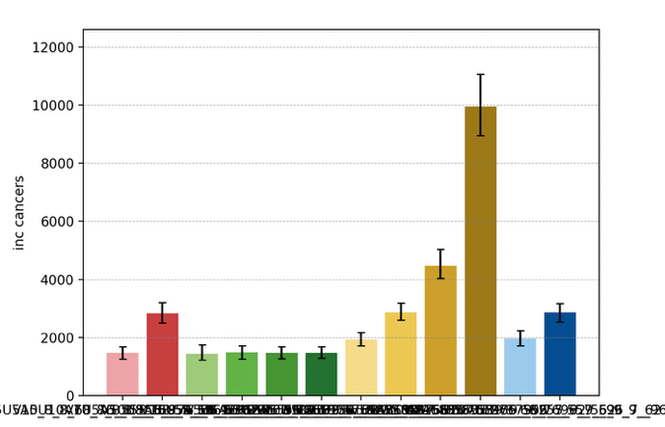
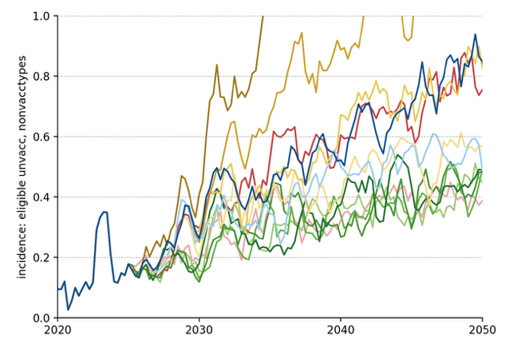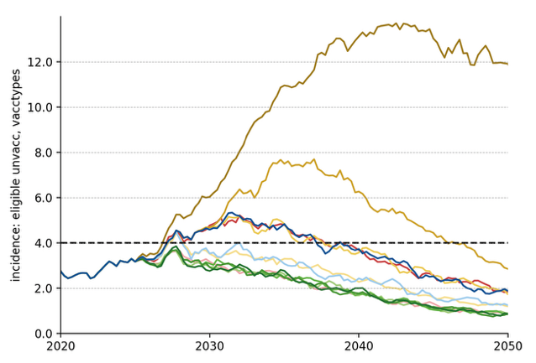
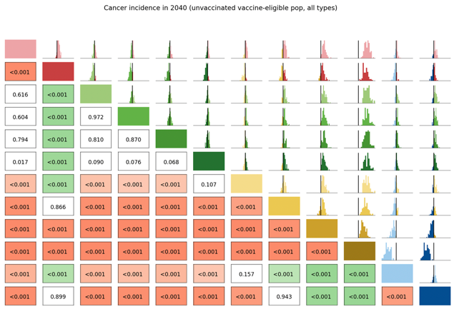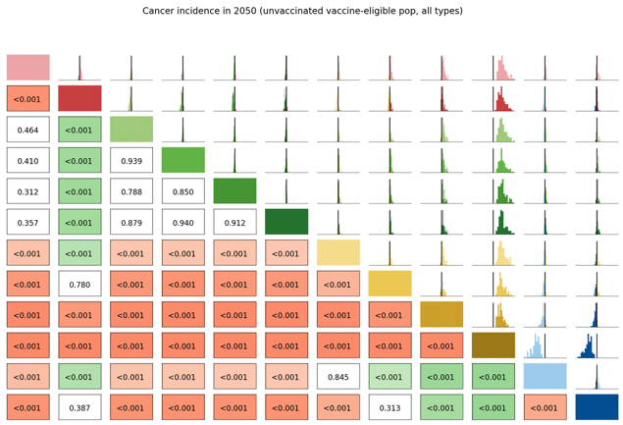

Long Term Undiagnosed Prevalence
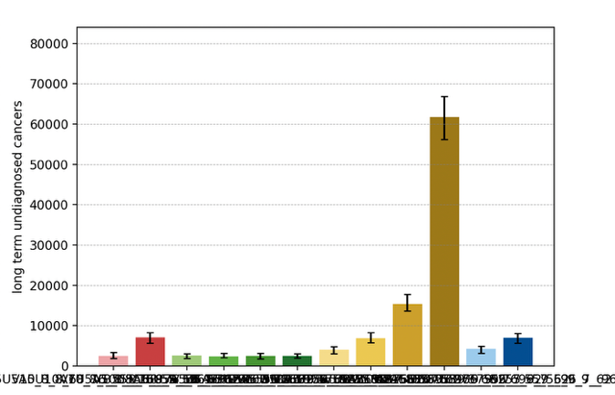
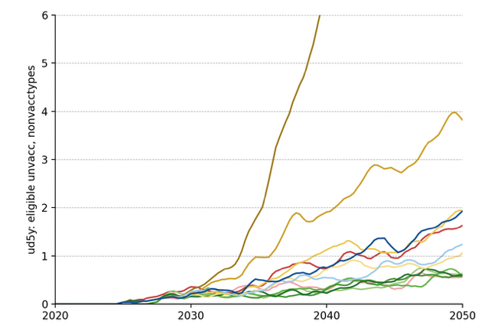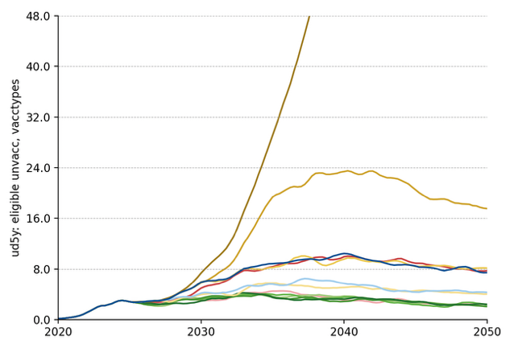
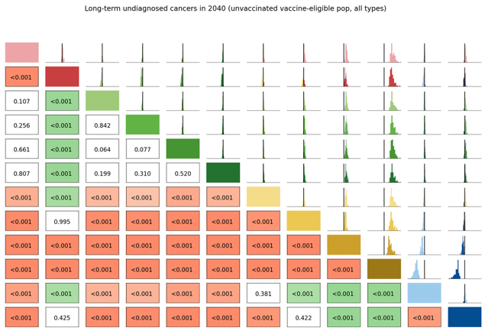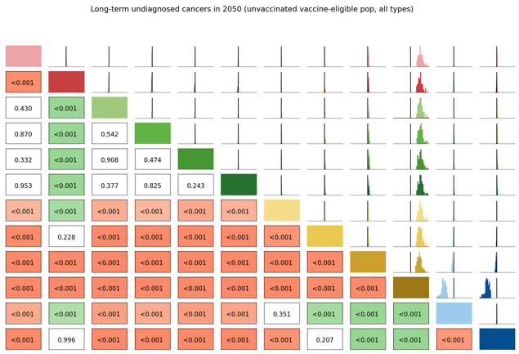

Number of Routine Screens
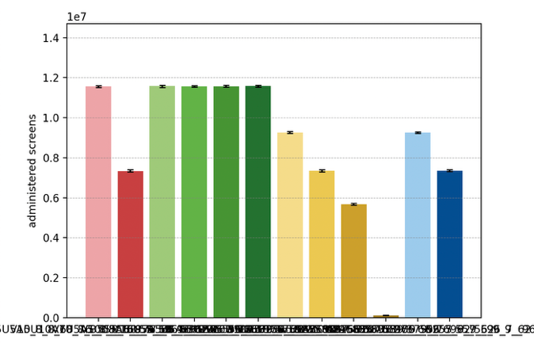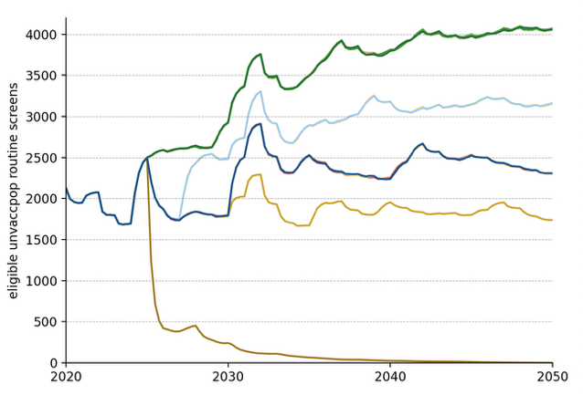

Average Number of Screens per Diagnosed Cancer, 2030-50
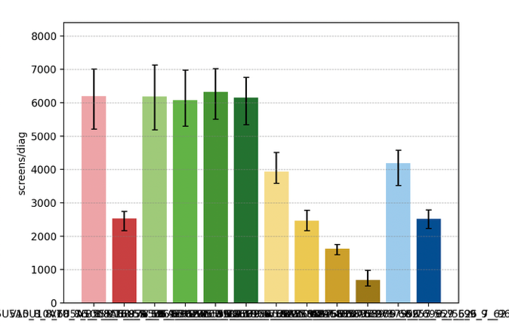

Elimination Probability Table
alg | Elimination Year: Median [LQ, UQ] (_8) | 2040.25 Elimination Probability (_8) | 2050.25 Elimination Probability (_8)
V5U5A5 | 2038 [2034, 2042] | 0.641 | 0.877
V7U5A5 | 2039 [2035, 2042] | 0.618 | 0.888
V10U5A5 | 2038 [2035, 2042] | 0.652 | 0.900
V15U5A5 | 2038 [2036, 2041] | 0.663 | 0.855
V_U5A5 | 2038 [2035, 2041] | 0.674 | 0.855
V7U7A5 | 2043 [2039, 2047] | 0.348 | 0.798
V10U10A5 | 2049 [2046, 2054] | 0.067 | 0.551
V15U15A5 | 2054 [2052, 2055] | 0.022 | 0.168
V_U_A5 | 2056 [2056, 2056] | 0.022 | 0.022
V10U7A5 | 2044 [2040, 2048] | 0.281 | 0.776
V15U10A5 | 2048 [2045, 2054] | 0.067 | 0.584
V10U10A10 | 2049 [2046, 2054] | 0.044 | 0.539
Maximum margin: 0.10363266055508763

